 |  | ADVANCED PROGRAMMING + DBMS
 | MID-SEMESTER ASSESSMENT CARD
TEAM 15 |  |  |  |  |  | AMRITA VISHWA VIDYAPEETHAM, CHENNAI
  TEAM MEMBERS  ANIKET MISHRA  CH.EN.U4CYS20004  JYOTHIKA NAMBIAR  CH.EN.U4CYS20032  KADIYALA RISHIKESH  CH.EN.U4CYS20033  SHRADDHA CHOPRA  CH.EN.U4CYS20068 |  |  |  |  | SUBMITTED TO  DR. V MURALIDARAN  Assistant Professor  Department of Computer Science and Engineering  DR. RAGUPATHY P  Assistant Professor  Department of Computer Science and Engineering |  |  |  | ADVANCED PROGRAMMING  DATABASE MANAGEMENT SYSTEMS
SUBMITED ON
18TH DECEMBER, 2021

BY TEAM 15
CYBER SECURITY
ODD SEMESTER
2ND YEAR

USING THE SOFTWARE

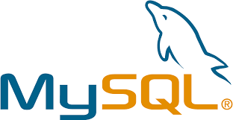



  MID-SEMESTER ASSESSMENT CARD  ADVANCED PROGRAMMING  +  DATABASE MANAGEMENT SYSTEMS | TABLE CHOSEN:  The name of our project is MID-SEMESTER ASSESSMENT CARD. blueprint of a Report card or Assessment Card but based on all the data and information that we collected from our mid-semester marksheet for Advanced Programming and Database and Management systems. It is similar to a report card but we have tweaked it a little by adding in various parameters of comparison and reasoning such as printing the ranks of all the students whose viva was taken by a particular faculty member or the option to see which student has scored the most in the chosen subject.  MOTIVATION FOR CHOOSING THE TOPIC:  We wanted to incorporate database management systems and programming in such a way that it can be useful in a realistic scenario.  While we were choosing our topic, it was the time when we were being presented with our midsemester marks. With a class strength of 87, it is quite difficult to manage the huge amount of data that is presented to us in the form of marks. We thought of blending these two ideas together in such a way that it can be helpful to those trying to compare or check.  We thought of making a report card system that would help students find out potentially what their ranks in class are, how well they have performed in viva and under which faculty their marks were the highest. This project was made keeping in mind the real-time and real-world use of database systems and programming languages.  APPROACH FOR SOLVING THE PROBLEM:  This project is an amalgam of database systems and programming so methods of incorporating them together was our first plan of action.  Using a mind-map we first broke down the project to its various components, mentioning all of its parameters and attributes. We then found ways in which every aspect can be made user friendly from data collection to date presentation.  Most of our planning went into assuring that both the frontend and backend were in sync with one another.

MID-SEMESTER ASSESSMENT CARD  ADVANCED PROGRAMMING  +  DATABASE MANAGEMENT SYSTEMS | ANY DIFFICULTIES FACED (AND HOW WE SOLVED THEM):  Choosing between the two programming languages was quite a task at first. On one hand we had C++ which was familiar and easy to use and on the other hand we had Python which was advanced, came with a lot of elaborate in-built functions and is easier to connect with backend. In the end, sophistication won against familiarity and ended up choosing Python as our programming language.  During execution we realized that there were quite many glitches in connecting frontend and backend but with the help of a few YouTube videos and help from our faculty members we managed to resolve that.  We also found it slightly laborious to create every single one of the 19 cases one by one but on the suggestion of one of our team members we managed to combine a lot of them together and reduce redundancy and time of execution.  In the middle of our coding, we realized that if there were multiple top scorers for a subject, our code was only printing the one with the smallest roll number. The code and backend weren’t supporting multiple answers and to solve this we had to learn many new database commands and implement it.  NEW THINGS WE LEARNT THROUGH THIS PROJECT:  We learnt how to work with backend and frontend simultaneously. We got to practice all the theory and knowledge we had acquired this semester in a more realistic and practical way. Python wasn’t our strongest forte before this project but after having worked on this code, we are much more familiarized and comfortable with using it.  IMPLEMENTATION DETAILS:  For our project, we implemented Python and SQL using the software - Visual Studio Code and MySQL. We mainly used commands from TCL, DML and DCL under SQL.  In our code, we have started off by prompting the user to choose among the multiple options given to manipulate the students’ marks information. On choosing one of the criterions, they are taken to the function that handles that particular option. There are many sub-parts to each option, thus giving the user a variety of alternatives to work with.  We have allowed the user to store, access, delete and manipulate students’ mark’s data, to retrieve the highest scorer in each subject, and the ranks according to a particular viva teacher.

DATABASE DESIGN
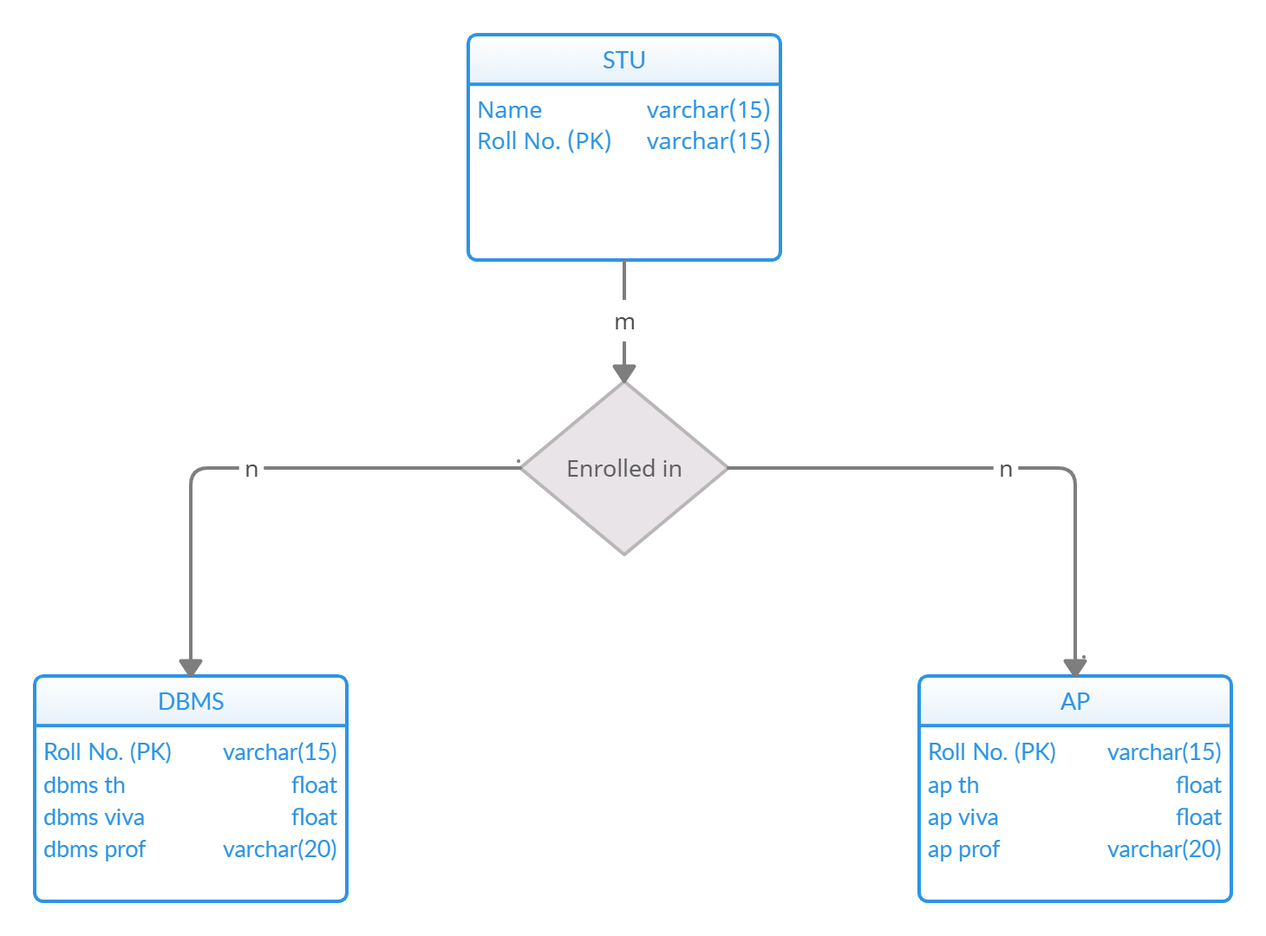

TABLE DESCRIPTION

AP Table
Roll no. | varchar
ap th | float
ap viva | float
ap prof | varchar
STU Table
Roll no. | varchar
Name | varchar
DBMS Table
Roll no. | varchar
dbms th | float
dbms viva | float
dbms prof | varchar

ENTITY RELATIONSHIP
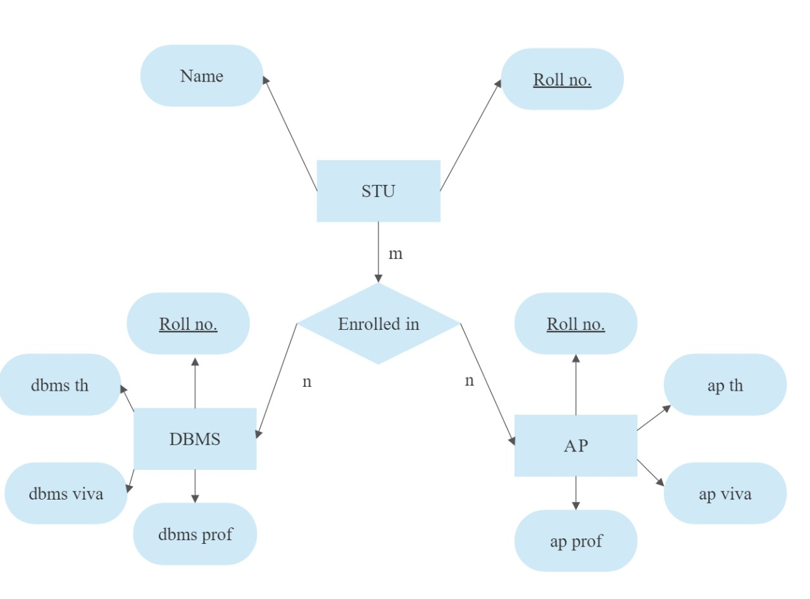

SYMBOL MEANING

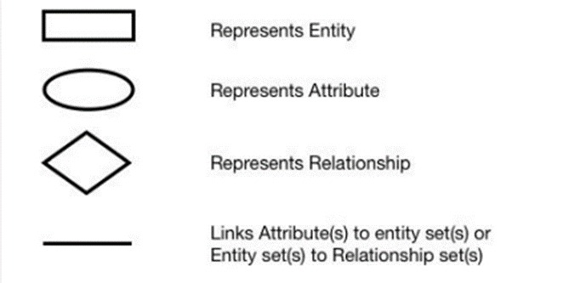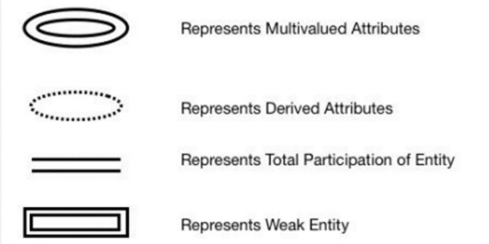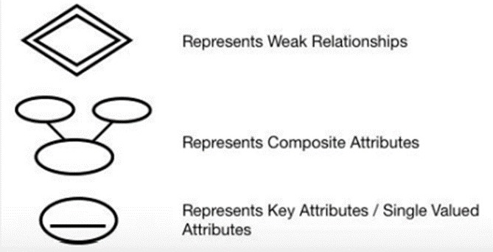

CODE

import mysql.connector as driver
import sys
def main_menu():
loop="y"
while loop=="y":
print("\n...................USER MENU......................")
print("1. CREATE DATABASE")
print("2. SHOW DATABASES")
print("3. CREATE STUDENT TABLE")
print("4. CREATE Advanced Programming Table")
print("5. CREATE DataBase Management System Table")
print("6. SHOW TABLES")
print("7. ADD Student's Record")
print("8. ADD STUDENT'S Advanced Programming Record")
print("9. ADD STUDENT'S DataBase Management System Record")
print("10. UPDATE Advanced Programming Record")
print("11. UPDATE DataBase Management System Record")
print("12. DELETE Advanced Programming Record")
print("13. DELETE DataBase Management System Record")
print("14. SEARCH Advanced Programming Record")
print("15. SEARCH DataBase Management System Record")
print("16. DISPLAY Advanced Programming Record")
print("17. DISPLAY DataBase Management System Record")
print("18. DISPLAY Advanced Programming Topper Record")
print("19. DISPLAY DataBase Management System Topper Record")
print("20. QUIT")
print()
choice=int(input("Enter the choice (1-20) : "))
if(choice==1):
create_database()
elif(choice==2):
show_databases()
elif(choice==3):
create_stud_table()
elif(choice==4):
create_ap_table()
elif(choice==5):
create_dbms_table()
elif(choice==6):
show_tables()
elif(choice==7):
insert_stud_record()
elif(choice==8):
insert_ap_record()
elif(choice==9):
insert_dbms_record()
elif(choice==10):
update_ap_record()
elif(choice==11):
update_dbms_record()
elif(choice==12):
delete_ap_record()
elif(choice==13):
delete_dbms_record()
elif(choice==14):
search_ap_record()
elif(choice==15):
search_dbms_record()
elif(choice==16):
display_ap_record()
elif(choice==17):
display_dbms_record()
elif(choice==18):
display_ap_top_record()
elif(choice==19):
display_dbms_top_record()

elif(choice==20):
break
else:
print("Wrong Choice.")
loop=input("\nDo you want to continue?(y or n)")
else:
sys.exit()

def create_database():
con=driver.connect(host="localhost",user="root",passwd="622001",port="3306",charset='utf8')
if con.is_connected():
print("Successfully Connected")
cur=con.cursor()
cur.execute('create database if not exists test')
print()
print("Database Created")
con.close()

def show_databases():
con=driver.connect(host='localhost',user='root',passwd='622001',charset='utf8',port="3306")
if con.is_connected():
print("Successfully Connected")
cur=con.cursor()
cur.execute('show databases')
for i in cur:
print(i)
con.close()

def create_stud_table():
con=driver.connect(host='localhost',user='root',passwd='622001',charset='utf8',database='test',port="3306")
if con.is_connected():
print("Successfully Connected")
cur=con.cursor()
cur.execute('create table if not exists stu(rollno varchar(15) primary key, name varchar(15))')
print()
print("Table Created -> stu")
cur.execute('DESC stu')
print("+-------------|--------------|-----------+")
print("+Column Name |DataType(Size)|NULL |")
print("+-------------|--------------|-----------+")

for i in cur:
print('|{0:12} | {1:12} | {2:10}|'.format(i[0],i[1].decode('UTF-8'),i[2]))
print("+-------------|--------------|-----------+")
con.close()

def create_ap_table():
con=driver.connect(host='localhost',user='root',passwd='622001',charset='utf8',database='test',port="3306")
if con.is_connected():
print("Successfully Connected")
cur=con.cursor()
cur.execute('create table if not exists AP(rollno varchar(15) primary key, apth float, apviva float, approf varchar(20))')
print()
print("Table Created -> AP")
cur.execute('DESC AP')
print("+-------------|--------------|-----------+")
print("+Column Name |DataType(Size)|NULL |")
print("+-------------|--------------|-----------+")

for i in cur:
print('|{0:12} | {1:12} | {2:10}|'.format(i[0],i[1].decode('UTF-8'),i[2]))
print("+-------------|--------------|-----------+")
con.close()

def create_dbms_table():
con=driver.connect(host='localhost',user='root',passwd='622001',charset='utf8',database='test',port="3306")
if con.is_connected():
print("Successfully Connected")
cur=con.cursor()
cur.execute('create table if not exists DBMS(rollno varchar(15) primary key, dbmsth float, dbmsviva float, dbmsprof varchar(20))')
print()
print("Table Created -> DBMS")
cur.execute('DESC DBMS')
print("+-------------|--------------|-----------+")
print("+Column Name |DataType(Size)|NULL |")
print("+-------------|--------------|-----------+")

for i in cur:
print('|{0:12} | {1:12} | {2:10}|'.format(i[0],i[1].decode('UTF-8'),i[2]))
print("+-------------|--------------|-----------+")
con.close()

def show_tables():
con=driver.connect(host='localhost',user='root',passwd='622001',charset='utf8',database='test',port="3306")
if con.is_connected():
print("Successfully Connected")
cur=con.cursor()
cur.execute('show tables')
for i in cur:
print(i)
con.close()

def insert_stud_record():
con=driver.connect(host='localhost',user='root',passwd='622001',charset='utf8',database='test',port="3306")
if con.is_connected():
print("Successfully Connected")
cur=con.cursor()
rollno=(input("ENTER student rollno : "))
NAME=input("ENTER Name OF student : ")

query1="INSERT INTO stu(rollno,name) VALUES('{}','{}')".format(rollno,NAME)
cur.execute(query1)
con.commit()
print('Record Inserted')
con.close()
else:
print("Error : Not Connected")

def insert_ap_record():
con=driver.connect(host='localhost',user='root',passwd='622001',charset='utf8',database='test',port="3306")
if con.is_connected():
print("Successfully Connected")
cur=con.cursor()
rollno=(input("ENTER student rollno : "))
apth=eval(input("enter marks in theory : "))
apviva=eval(input("enter viva marks : "))
approf=input("enter name of the professor who took viva in Advanced Programming : ")

query1="INSERT INTO AP(rollno,apth,apviva,approf) VALUES('{}',{},{},'{}')".format(rollno,apth,apviva,approf)
cur.execute(query1)
con.commit()
print('Record Inserted')
con.close()
else:
print("Error : Not Connected")

def insert_dbms_record():
con=driver.connect(host='localhost',user='root',passwd='622001',charset='utf8',database='test',port="3306")
if con.is_connected():
print("Successfully Connected")
cur=con.cursor()
rollno=(input("ENTER student rollno : "))
dbmsth=eval(input("enter marks in theory : "))
dbmsviva=eval(input("enter viva marks : "))
dbmsprof=input("enter name of the professor who took viva in DataBase Management System : ")

query1="INSERT INTO DBMS(rollno,dbmsth,dbmsviva,dbmsprof) VALUES('{}',{},{},'{}')".format(rollno,dbmsth,dbmsviva,dbmsprof)
cur.execute(query1)
con.commit()
print('Record Inserted')
con.close()
else:
print("Error : Not Connected")

def update_ap_record():
con=driver.connect(host='localhost',user='root',passwd='622001',charset='utf8',database='test',port="3306")
cur=con.cursor()

rollno=(input("enter Student rollno : "))
apth=eval(input("enter marks in theory to be updated : "))
apviva=eval(input("enter viva marks to be updated : "))

query1="update AP set rollno=%s apth=%s , apviva=%s where rollno=%s" %(rollno,apth,apviva)
cur.execute(query1)
con.commit()
print("Record Updated")
con.close()

def update_dbms_record():
con=driver.connect(host='localhost',user='root',passwd='622001',charset='utf8',database='test',port="3306")
cur=con.cursor()

rollno=(input("enter Student rollno : "))
dbmsth=eval(input("enter marks in theory to be updated : "))
dbmsviva=eval(input("enter viva marks to be updated : "))

query1="update DBMS set rollno=%s dbmsth=%s , dbmsviva=%s where rollno=%s" %(rollno,dbmsth,dbmsviva)
cur.execute(query1)
con.commit()
print("Record Updated")
con.close()

def delete_ap_record():
con=driver.connect(host='localhost',user='root',passwd='622001',charset='utf8',database='test',port="3306")
cur=con.cursor()
d=(input("Enter student rollno for deleting record : "))
query1="delete from AP where rollno={0}".format(d)
cur.execute(query1)
con.commit()
print("Record Deleted")
con.close()

def delete_dbms_record():
con=driver.connect(host='localhost',user='root',passwd='622001',charset='utf8',database='test',port="3306")
cur=con.cursor()
d=(input("Enter student rollno for deleting record : "))
query1="delete from DBMS where rollno={0}".format(d)
cur.execute(query1)
con.commit()
print("Record Deleted")
con.close()

def search_ap_record():
con=driver.connect(host='localhost',user='root',passwd='622001',charset='utf8',database='test',port="3306")
cur=con.cursor()
print("enter the choice according to which you have to search in AP record: ")
print("1. According to roll number")
print("2. According TO Viva Professor's Name")
print("3. According to theory marks")
print("4. According to viva marks")
print()
choice=int(input("ENTER THE CHOICE (1-4) : "))
if choice==1:
d=(input("Enter student rollno which you want to search : "))
query1="select * from AP where rollno=%s" %(d)
elif choice==2:
name=input("Enter Viva Professor's Name which you want to search : ")
query1="select * from AP where name='%s'" %(name)
elif choice==3:
th_mark=float(input("Enter theory marks which you want to search : "))
query1="select * from AP where marks=%s" %(th_mark)
elif choice==4:
viva_mark=float(input("Enter viva marks which you want to search : "))
query1="select * from AP where marks=%s" %(viva_mark)
else:
print("Wrong Choice")
cur.execute(query1)
rec=cur.fetchall()
count=cur.rowcount
print("Total no. of records found : ",count)
for i in rec:
print(i)
print("Record Searched")
con.close()

def search_dbms_record():
con=driver.connect(host='localhost',user='root',passwd='622001',charset='utf8',database='test',port="3306")
cur=con.cursor()
print("enter the choice according to which you have to search in DBMS record: ")
print("1. According to roll number")
print("2. According TO Viva Professor's Name")
print("3. According to theory marks")
print("4. According to viva marks")
print()
choice=int(input("ENTER THE CHOICE (1-4) : "))
if choice==1:
d=(input("Enter student rollno which you want to search : "))
query1="select * from DBMS where rollno=%s" %(d)
elif choice==2:
name=input("Enter Viva Professor's Name which you want to search : ")
query1="select * from DBMS where name='%s'" %(name)
elif choice==3:
th_mark=float(input("Enter theory marks which you want to search : "))
query1="select * from DBMS where marks=%s" %(th_mark)
elif choice==4:
viva_mark=float(input("Enter viva marks which you want to search : "))
query1="select * from DBMS where marks=%s" %(viva_mark)
else:
print("Wrong Choice")
cur.execute(query1)
rec=cur.fetchall()
count=cur.rowcount
print("Total no. of records found : ",count)
for i in rec:
print(i)
print("Record Searched")
con.close()

def display_ap_record():
con=driver.connect(host='localhost',user='root',passwd='622001',charset='utf8',database='test',port="3306")
if con.is_connected():
print("Successfully Connected")
cur=con.cursor()
cur.execute('select * from AP')
rec=cur.fetchall()
count=cur.rowcount
print("Advanced Programming Record is as follows: ")
print()
print("+---------------|------------------|----------------|--------------------+")
print("| Roll Number | Theory Marks | Viva Marks | Viva Professor |")
print("+---------------|------------------|----------------|--------------------+")
for i in rec:
print('|{0:^11} | {1:^16} | {2:^15}|{3:^20}|'.format(i[0],i[1],i[2],i[3]))
print("+---------------|------------------|----------------|--------------------+")
print("| Total no. of records are : ",count," |")
print("+------------------------------------------------------------------------+")
con.close()
else:
print("Error : Database Connection is not success")

def display_dbms_record():
con=driver.connect(host='localhost',user='root',passwd='622001',charset='utf8',database='test',port="3306")
if con.is_connected():
print("Successfully Connected")
cur=con.cursor()
cur.execute('select * from DBMS')
rec=cur.fetchall()
count=cur.rowcount
print("DataBase Management System Record Is As Follows: ")
print()
print("+--------------|------------------|----------------|--------------------+")
print("| Roll Number | Theory Marks | Viva Marks | Viva Professor |")
print("+--------------|------------------|----------------|--------------------+")
for i in rec:
print('|{0:^13} | {1:^16} | {2:^15}|{3:^20}|'.format(i[0],i[1],i[2],i[3]))
print("+--------------|------------------|----------------|--------------------+")
print("| Total no. of records are : ",count," |")
print("+----------------------------------------------------------------------+")

con.close()
else:
print("Error : Database Connection is not success")

def display_ap_top_record():
con=driver.connect(host='localhost',user='root',passwd='622001',charset='utf8',database='test',port="3306")
if con.is_connected():
print("Successfully Connected")
cur=con.cursor()
cur.execute('select name from tes1, rollno from AP where SUM(apth,apviva) is MAX')

def display_ap_top_record():
con=driver.connect(host='localhost',user='root',passwd='622001',charset='utf8',database='test',port="3306")
cur=con.cursor()
print("Enter the choice according to which you have to search topper in Advanced Programming: ")

print("1. According to Viva Professor's Name")
print("2. According to theory marks")
print("3. According to viva marks")
print()
choice=int(input("ENTER THE CHOICE (1-3) : "))

if choice==1:
name=input("Enter Viva Professor's Name whose highest awarded marks you want to search : ")
query1="select stu.name, ap.rollno, ap.apviva from AP, stu where stu.rollno = ap.rollno and ap.approf ='%s'" %(name)
elif choice==2:

query1="SELECT stu.name, ap.rollno,ap.apth FROM AP INNER JOIN stu ON stu.rollno=ap.rollno where apth=(select max(apth) from AP)"
elif choice==3:

query1="SELECT stu.name, ap.rollno,ap.apviva FROM AP INNER JOIN stu ON stu.rollno=ap.rollno where apviva=(select max(apviva) from AP) "
else:
print("Wrong Choice")
cur.execute(query1)
rec=cur.fetchall()
count=cur.rowcount
print("Advanced Programming Record Is As Follows: ")
print()
print("+----------------|----------------|----------------+")
print("| Name | Roll Number | Max Marks |")
print("+----------------|----------------|----------------+")
for i in rec:
print('|{0:^15} |{1:^15} {2:^14} | '.format(i[0],i[1],i[2]))
print("+----------------|----------------|----------------+")
print("| Total records are : ",count," |")
print("+--------------------------------------------------+")
con.close()

def display_dbms_top_record():
con=driver.connect(host='localhost',user='root',passwd='622001',charset='utf8',database='test',port="3306")
cur=con.cursor()
print("Enter the choice according to which you have to search topper in DataBase Management System: ")

print("1. Rank Card According to Viva Professor's Name")
print("2. According to theory marks")
print("3. According to viva marks")
print()
choice=int(input("ENTER THE CHOICE (1-3) : "))

if choice==1:
name=input("Enter Viva Professor's Name whose highest awarded marks you want to search : ")
query1="select stu.name, dbms.rollno, dbms.dbmsviva from dbms, stu where stu.rollno = dbms.rollno and dbms.dbmsprof = '%s'" %(name)
elif choice==2:

query1=" SELECT stu.name, dbms.rollno, dbms.dbmsth FROM dbms INNER JOIN stu ON stu.rollno=dbms.rollno where dbmsth=(select max(dbmsth) from dbms)"
elif choice==3:

query1="SELECT stu.name, dbms.rollno, dbms.dbmsviva FROM dbms INNER JOIN stu ON stu.rollno=dbms.rollno where dbmsviva=(select max(dbmsviva) from dbms)"
else:
print("Wrong Choice")
cur.execute(query1)
rec=cur.fetchall()
count=cur.rowcount
print("DataBase Management System Record Is As Follows: ")
print()
print("+----------------|----------------|----------------+")
print("| Name | Roll Number | Max Marks |")
print("+----------------|----------------|----------------|")
for i in rec:
print('|{0:^15} |{1:^15} | {2:^14} | '.format(i[0],i[1],i[2]))
print("+----------------|----------------|----------------+")
print("| Total records are : ",count," |")
print("+--------------------------------------------------+")
con.close()

if __name__ == "__main__":
main_menu()

OUTPUT SCREENSHOTS

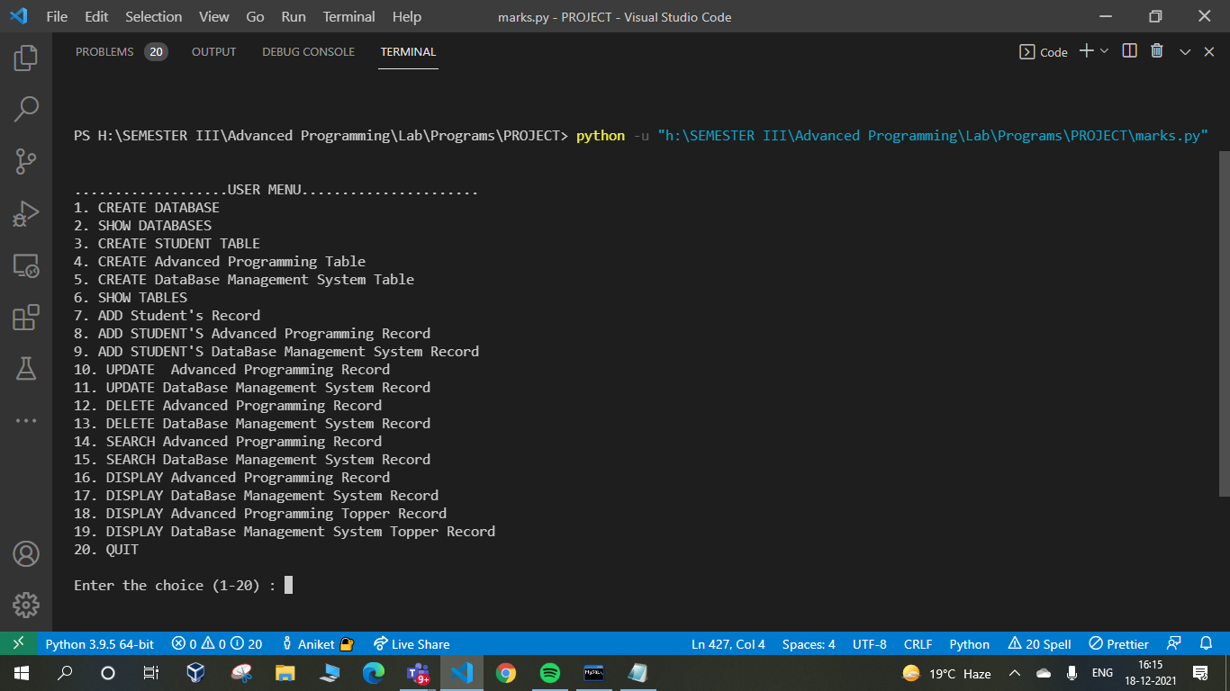
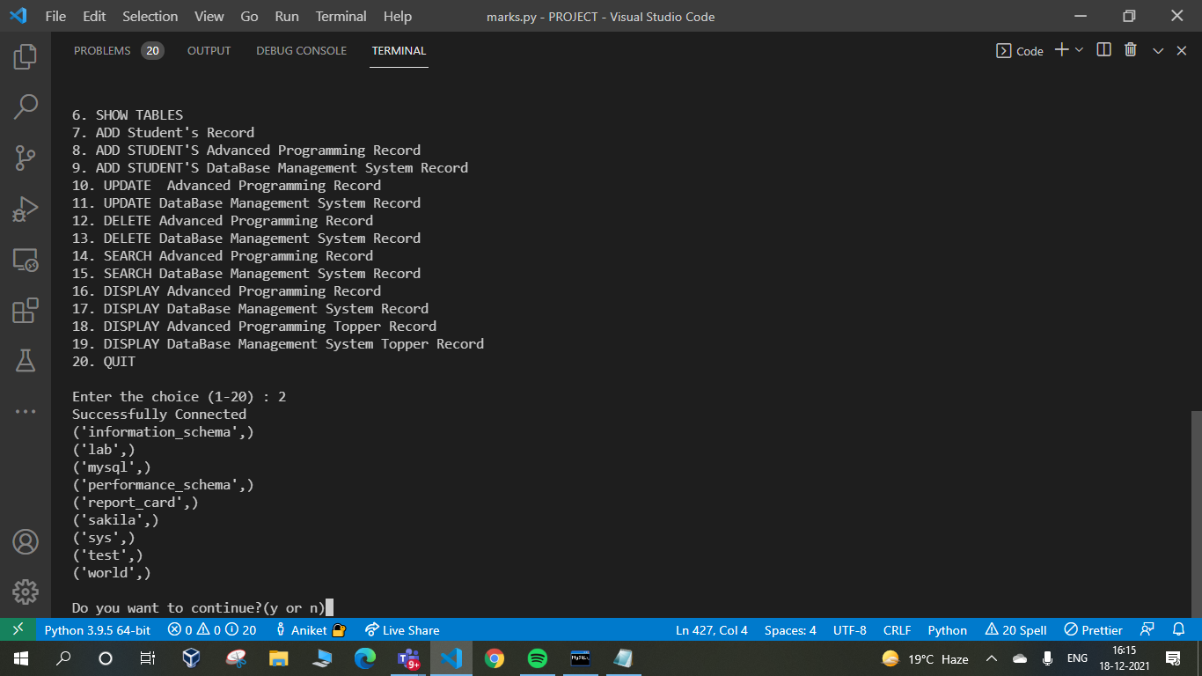
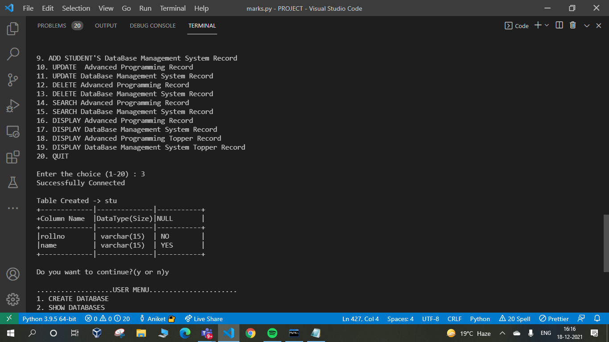

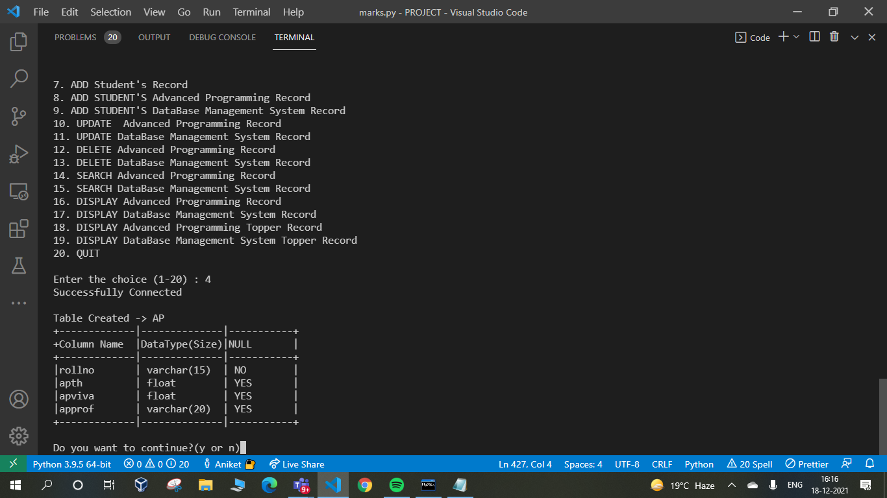
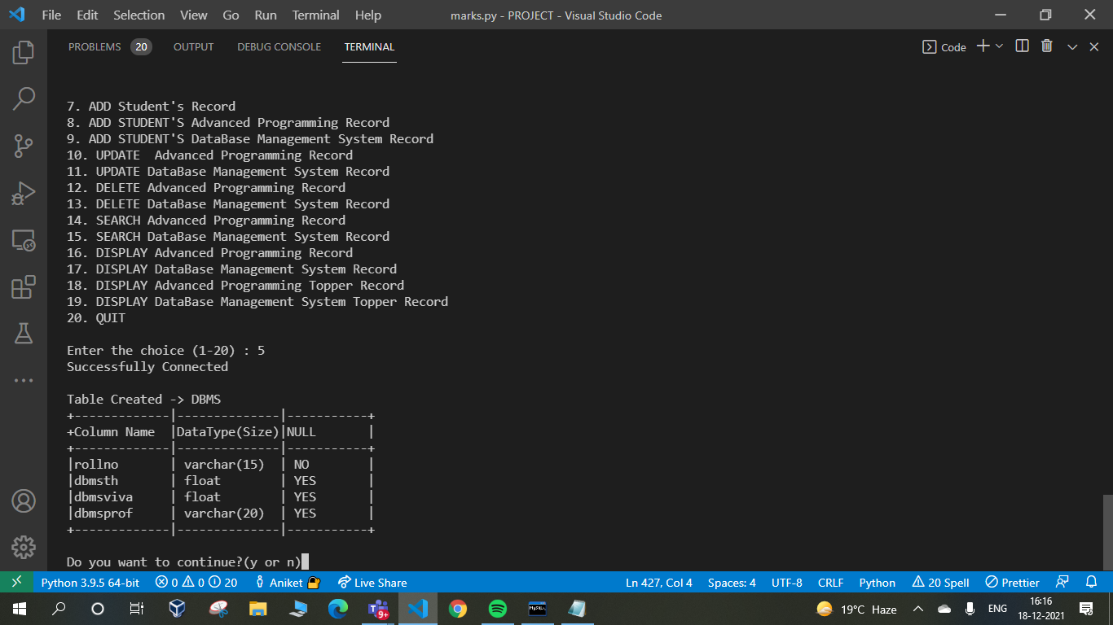

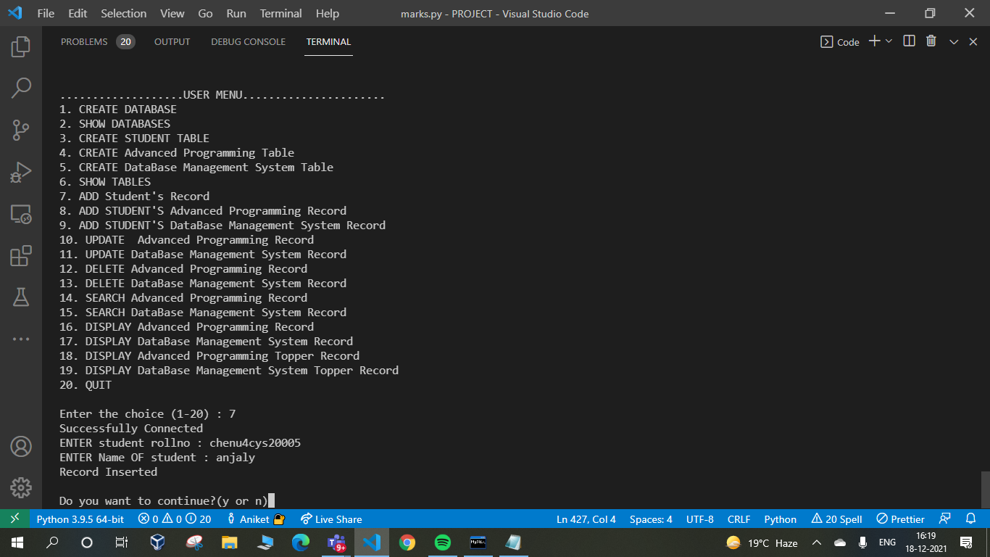
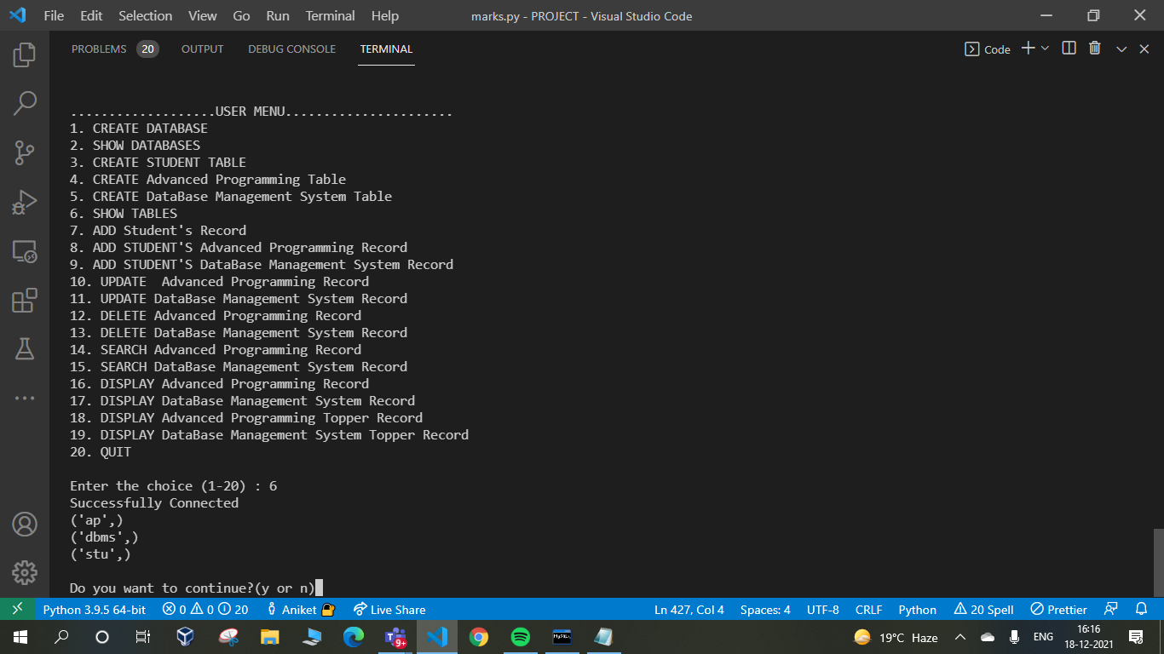
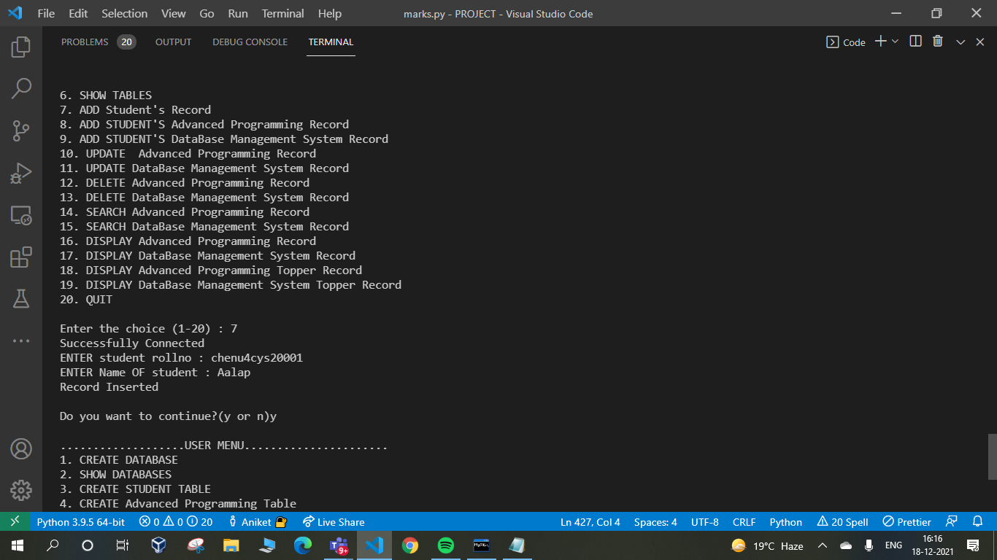

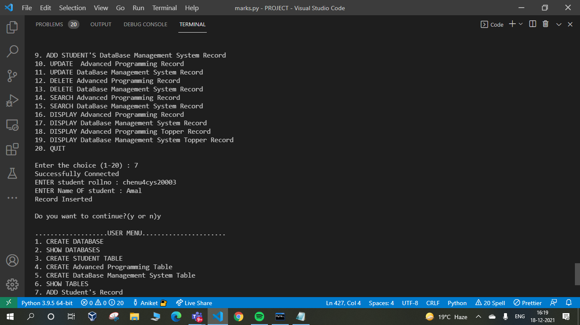
fes

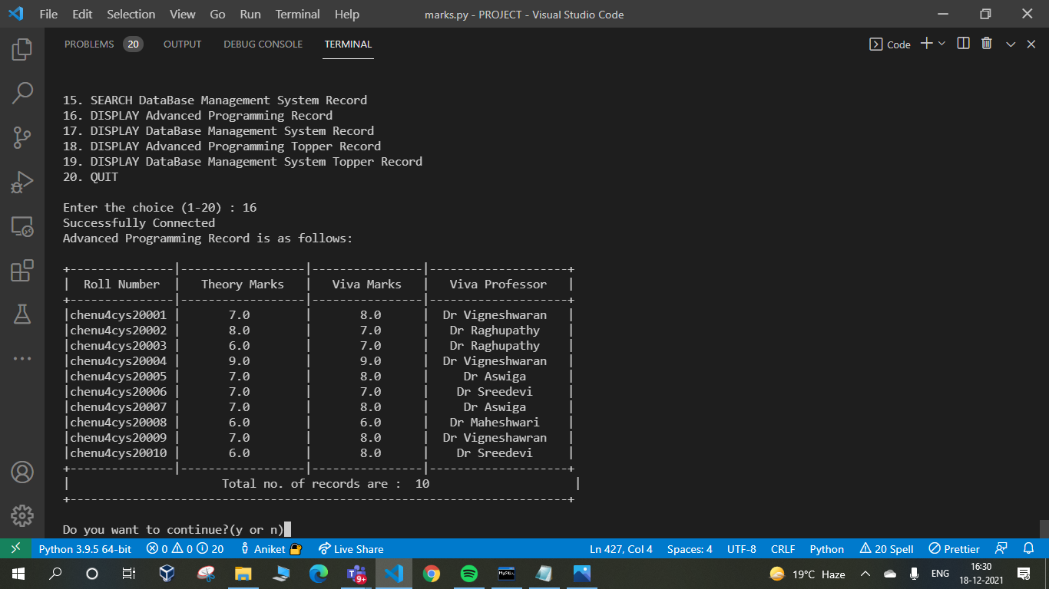
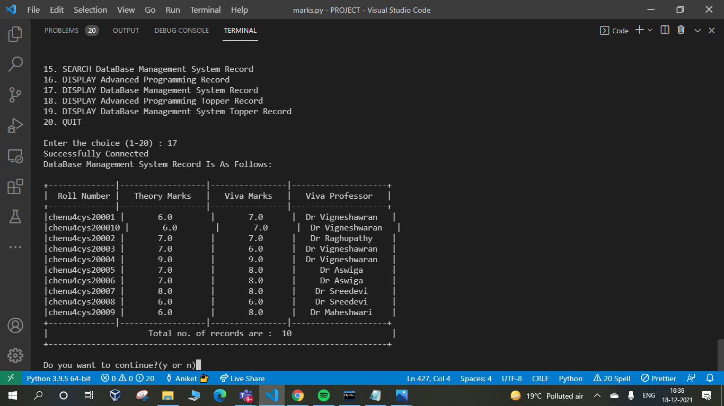

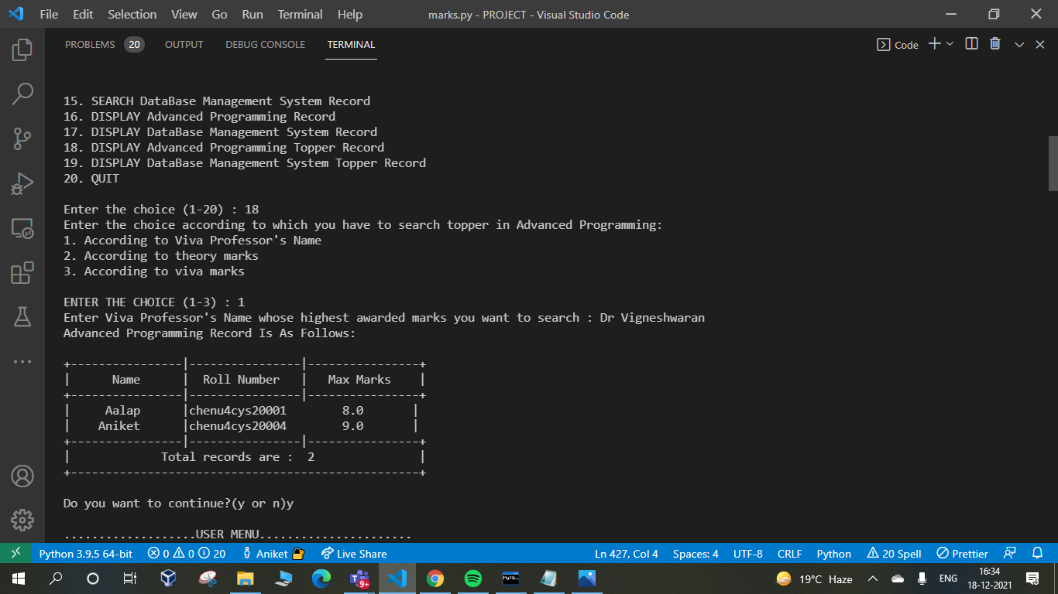

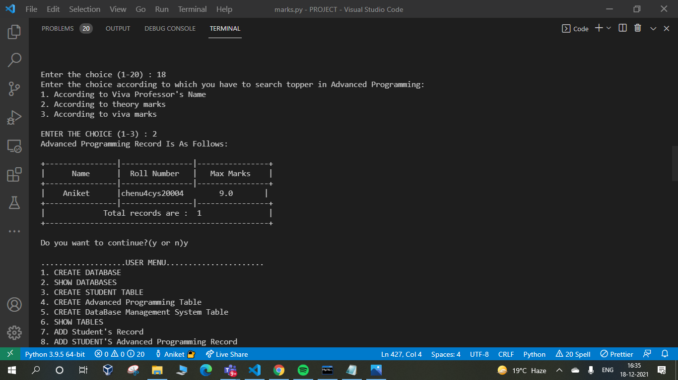

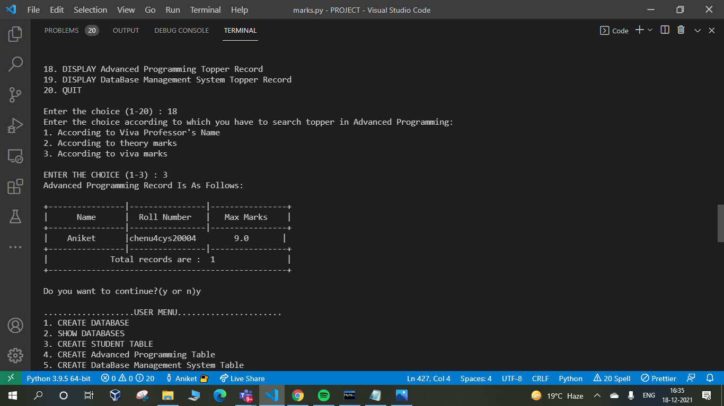
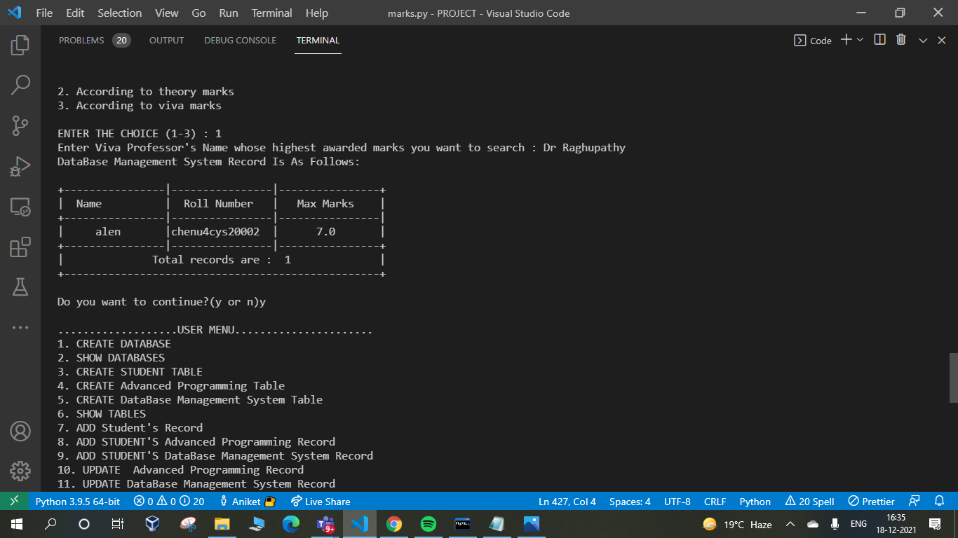

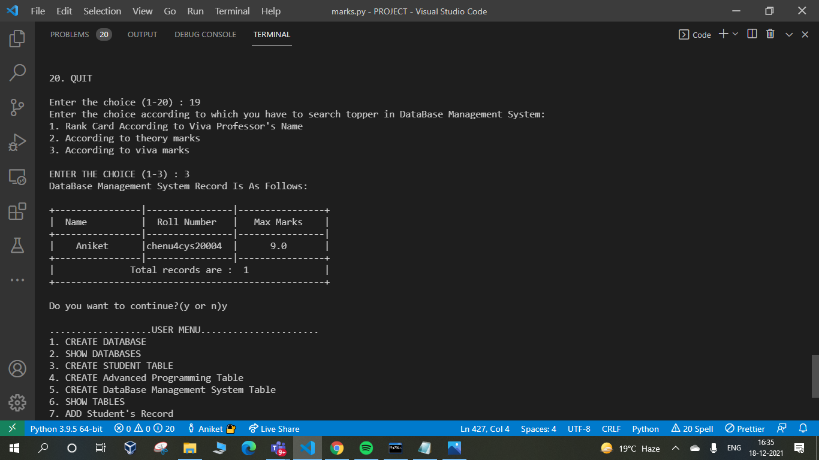

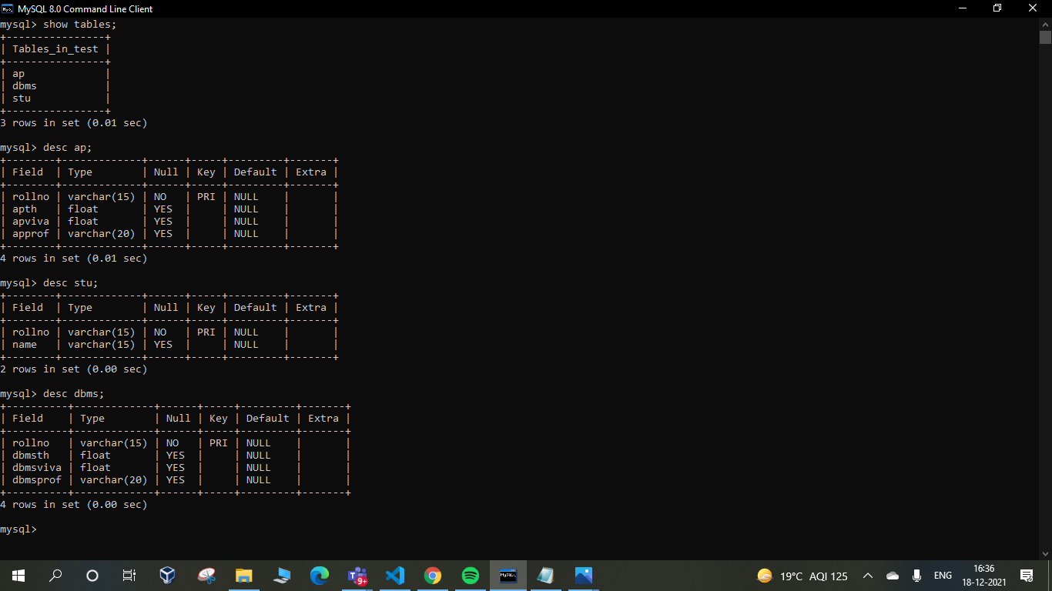

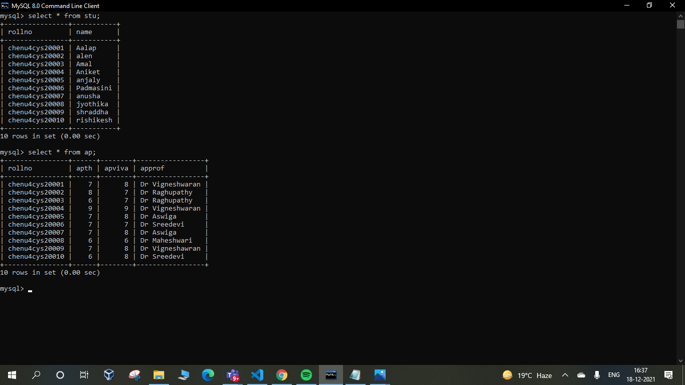

REFERENCES

- https://stackoverflow.com/questions/39149243/how-do-i-connect-to-a-sql-server-database-with-python

- https://www.tutorialspoint.com/python/python_database_access.htm

- https://www.w3schools.in/python-tutorial/database-connection/

- https://creately.com/diagram-type/database-design

- https://github.com/topics/dbms?l=python

- https://cloud.smartdraw.com/editor.aspx?templateId=da34e096-b9cb-4d56-a0ce-d9bdef138714&flags=128#depoId=31723575&credID=-36858967

- https://stackoverflow.com/questions/2655748/writing-a-dbms-in-python

- https://www.codewithc.com/pharmacy-management-system-c-mysql/#google_vignette

- https://docs.python.org/3/library/sqlite3.html

- https://www.freecodecamp.org/news/connect-python-with-sql/

